Using the Accessible PowerPoint template
- Download the Accessible PowerPoint template and save it under Documents > Custom Office Templates.
- Open PowerPoint
- Select New, then select the personal tab.
- Select the SMU Accessible PowerPoint Template. Then click Create in the popup window.

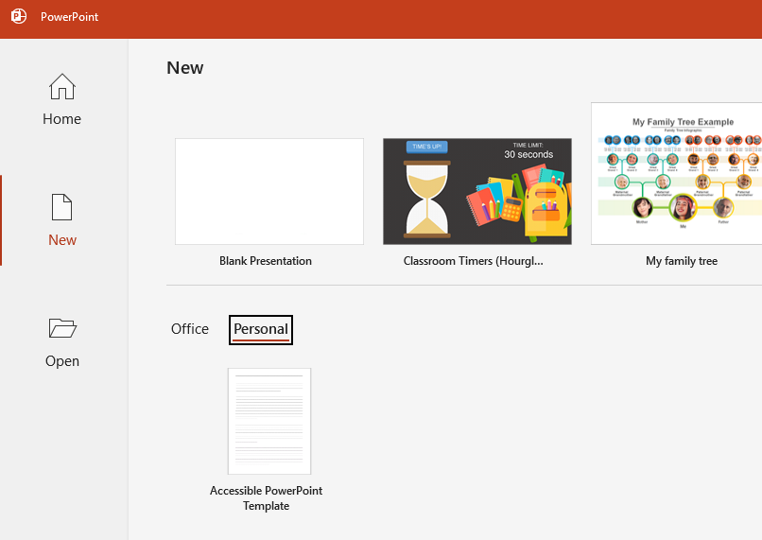
- Make sure to save your file and give it a meaningful name.
- Continue working on the slide deck as normal.

