Using the Accessible Word template
- Download the Accessible Word template and save it under Documents > Custom Office Templates.
- Open Word
- Select New, then select the personal tab.
- Select the SMU Accessible Word Template.
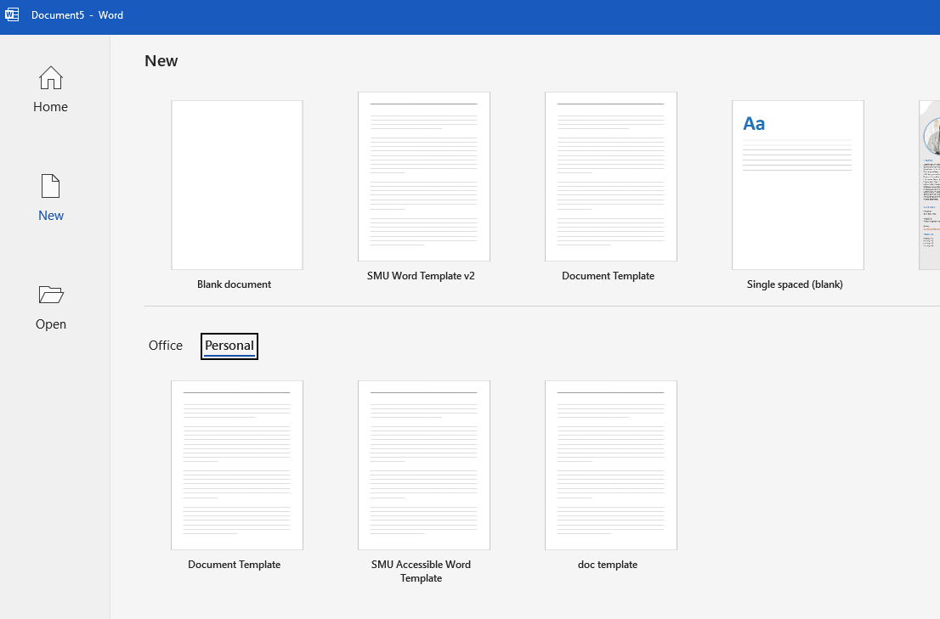
- Make sure to save your file and give it a meaningful name.
- Continue working on the document as normal.

